89 Starter relay Pic
http://www.naxja.org/forum/showthread.php?t=97288
Post #7 by Saudade
This thread has a great picture of the starter relay, and all the fusible links coming off it.
Note on 01-01-2015 photo is no longer available
http://www.naxja.org/forum/showthread.php?t=97288
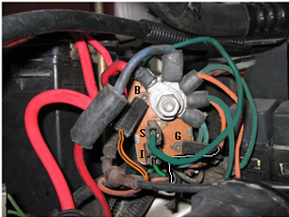

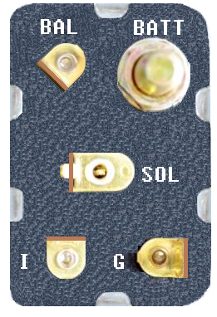
BAL= 14 ORG/BLK to Fuel Pump Ballast Resistor; hot after start up
SOL= 14 DK GRN to STARTER SOLENOID; hot when starting
I= 14 GRN from Ignition Switch Start Position; hot when starting
G= 18 BLK/WHT Ground from Transmission Natural Position; this must be grounded before starter relay can be energized

